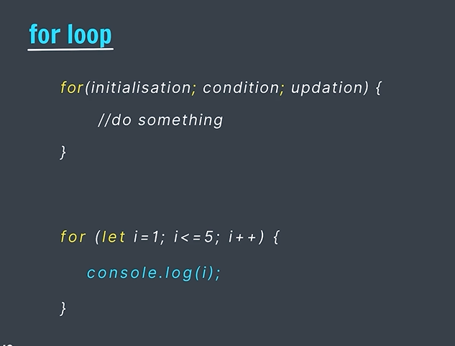

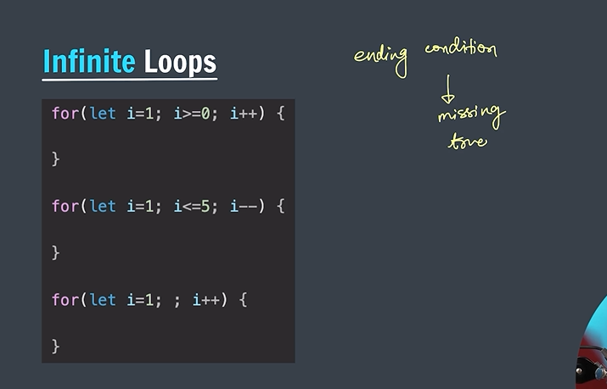

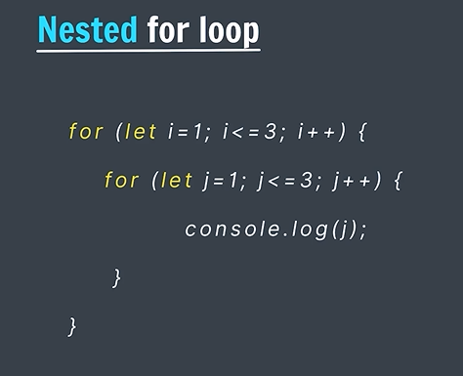

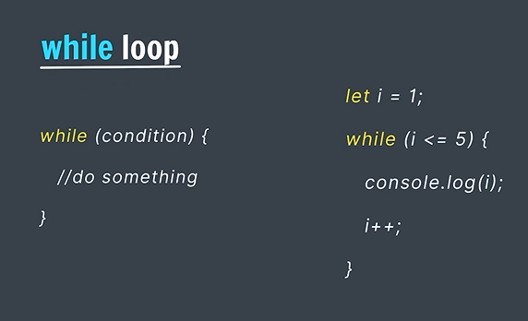

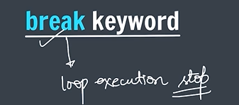

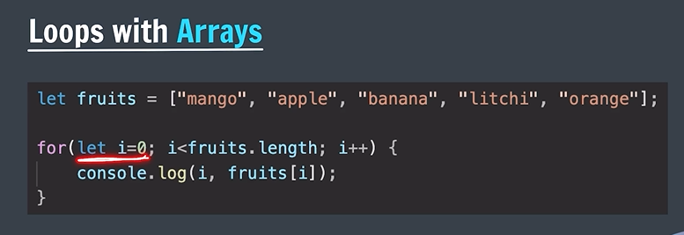

Nested Arrays

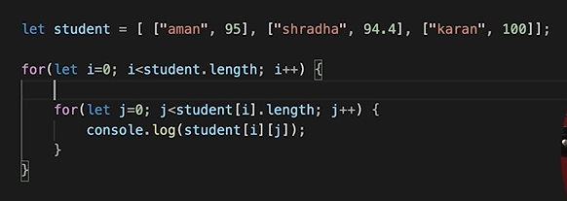

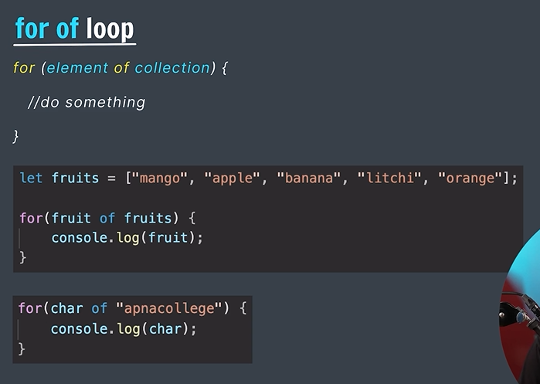

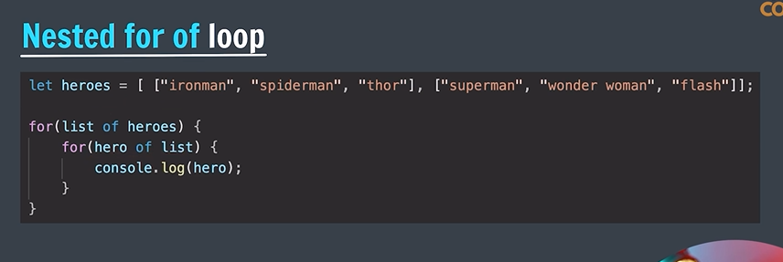

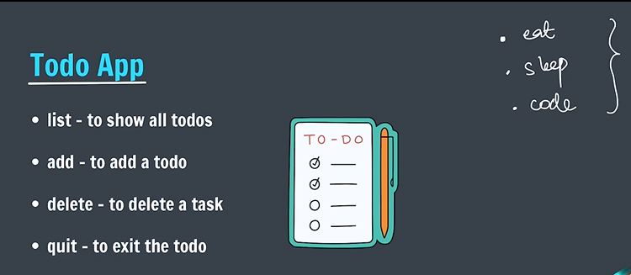

*/\*\**

*\* Represents a simple to-do app.*

*\* Allows users to add, delete, and list tasks.*

*\*/*

let todo = [];

let req = prompt("please enter your request");

while (true) {

    if(req == "quit") {

        console.log("quitting app");

        break;

    }

    if(req == "list") { *// Printing all task in console*

        console.log("\*\*\*\*\*\*\*\*\*\* TO DO LIST \*\*\*\*\*\*\*\*\*\*");

        for(let i = 0; i < todo.length; i++) {

            console.log(`${i+1}: ${todo[i]}`);

        }

        console.log("\*\*\*\*\*\*\*\*\*\*\*\*\*\*\*\*\*\*\*\*\*\*\*\*\*\*\*\*\*\*\*\*");

    } else if(req == "add") {

        let task = prompt("please enter your task");

        todo.push(task);

        console.log(`${task} added to the list`);

    } else if(req == "delete") {

        let index = parseInt(prompt("Enter task number for delete"));

        todo.splice(index-1, 1);

        console.log(`task at index ${index} deleted`);

    } else {

        console.log("please enter valid request!!");

    }

    req = prompt("please enter your request");

}